**Understanding User Retention for Duolingo**

Marena Keci

Loyola University Chicago

COMM 363-201: Research Methods in Advertising/PR

Cait Lackey

May 3, 2025

**Understanding User Retention for Duolingo**

            Duolingo is a leading American educational company best known for its app that provides language learning lessons but also offers math and music lessons. The company was founded in 2011 by Luis von Ahn and Severin Hacker. Its mission is to make education free and accessible for everyone. The platform includes over forty languages and incorporates learning in a fun way with its gamified lessons (Duolingo, 2025). Duolingo has 500 million registered users globally but only about 116 million monthly users as of 2024 (Ceci, 2024). The app contains an adaptive learning algorithm meant to enhance a user’s learning efficiency based on personalized lessons. Duolingo provides its basic learning service for free but also offers two different subscription services: Super Duolingo and Duolingo Max. The paid versions provide users with an ad-free version of the app and additional features meant to thoroughly explain and teach a language like “Explain my mistake” (Duolingo, 2025). The company has been exponentially growing since 2020, valued at 178 million dollars during the second quarter of 2024 (Ceci, 2024).

            This research explores the fact that only about 1 out of 5 registered users actively use the app and what keeps these consistent users coming back. The exploratory research question is: What factors contribute to high user retention, particularly among those with long streaks? For an app like Duolingo, user retention is extremely essential to its success. To further dive into this topic, it is important to understand the motivations, behaviors, and reasons behind sustained engagement. Exploring what motivates Duolingo users with long streaks to return to the app daily can provide valuable insights for Duolingo and for all companies looking to increase user retention. The formation of a consistent habit was studied by Charles Duhigg in 2012, introducing the theory of the habit loop, which is made up of cue, routine, and reward. Duhigg explains that cue is the trigger for an automatic behavior to start, routine is the behavior itself, and reward is what the brain gets out of it. “When cue and a behavior and a reward become neurologically intertwined, what’s actually happening is a neural pathway is developing that links those three things together in our head,” he says. (Duhigg, 2014). Before the research, I anticipated that long streak users were motivated to engage with the Duolingo app daily because of daily notifications, streak continuation, and a strong desire to learn and grow. My hypothesis incorporates Duhigg’s theory of the habit loop. Gamification and social accountability can also drive consistent user engagement based on research conducted by Juho Hamari, Jonna Koivisto, and Harri Sarsa (Hamari et al., 2014). Duolingo’s gamified features, which include streaks, leaderboards, and rewards, use a psychological framework that creates continuous engagement. However, this does not seem as effective for some Duolingo users, as many of them cannot commit to long-term use, as shown by the 1 in 5 statistic previously mentioned. This research will uncover the motivations and behaviors of current Duolingo users with long streaks. This data could lead to the discovery of new ways to engage Duolingo users who cannot commit to continuous usage. Snapchat, which pioneered the streak feature, shows that users can maintain daily usage. Snapchat streaks track consistent communication between users and encourage long-term usage (Vogels et al., 2022). I can provide actionable data for encouraging long-term user engagement by analyzing successful user retention among long-streak Duolingo users.

**Methodology**

            I used a mixed methods approach combining quantitative and qualitative data for the methodology. I collected the data from surveys and interviews. The survey was created on Google Forms and included nine closed-ended questions, one Likert scale question, three open-ended questions, one demographic question, and two questions asking permission to be contacted for further data. It was distributed in person on February 25, 2025, at 10:15 a.m. at the entrance of the School of Communications at Loyola University Chicago, Water Tower Campus. I asked every fifth student who entered the building through systematic sampling to take the survey. The survey was also distributed online on March 17, 2025, at 10:20 a.m. and March 31, 2025, at 10:20 a.m. on the Loyola 2025 Snapchat story, a private story on Snapchat only for Loyola students graduating in 2025, as a convenient sample. The posts included a photo of a classroom with the text reading, “I am collecting data on Duolingo for a research class. Please take a couple of minutes to fill out this survey, I would really appreciate it,” and a link to the survey was also included. Fifty-one people, ranging from ages 18 to 25, completed the survey. I also conducted three in-depth 30-minute interviews with long-streak users. I contacted eight survey respondents with long streaks who expressed willingness to be contacted for further data collection, and only three responded. The first interview featured someone with a 457-day streak and took place on Zoom on March 31, 2025, at 1:30 p.m. The second interviewee had a 392-day streak, and the interview was conducted over Zoom on April 9, 2025, at 5:00 p.m. The final interview featured someone with a 61-day streak and took place on Zoom on April 10, 2025, at 1:00 p.m.

After collecting all the data, I began analyzing the survey data on Google Sheets. I calculated the streak lengths’ mean, median, mode, and standard deviation. To effectively visualize the data, I created bar charts for the responses to the following questions: “Do you currently use Duolingo?” “What motivated you to return to an app daily?” “If you are a regular Duolingo user, what keeps you engaged with the app?” and “If you are not a regular user, what prevents you from using it regularly?” I also separated and organized the data from long streak users to create a bar chart of their motivations to compare to all responses. Additionally, I coded the open-ended questions and conducted a pilot study. For the interviews, I transcribed them using Otter AI, coded the common themes, ran a pilot study, identified quotes from each interview that matched the codes, and explored the themes and implications.

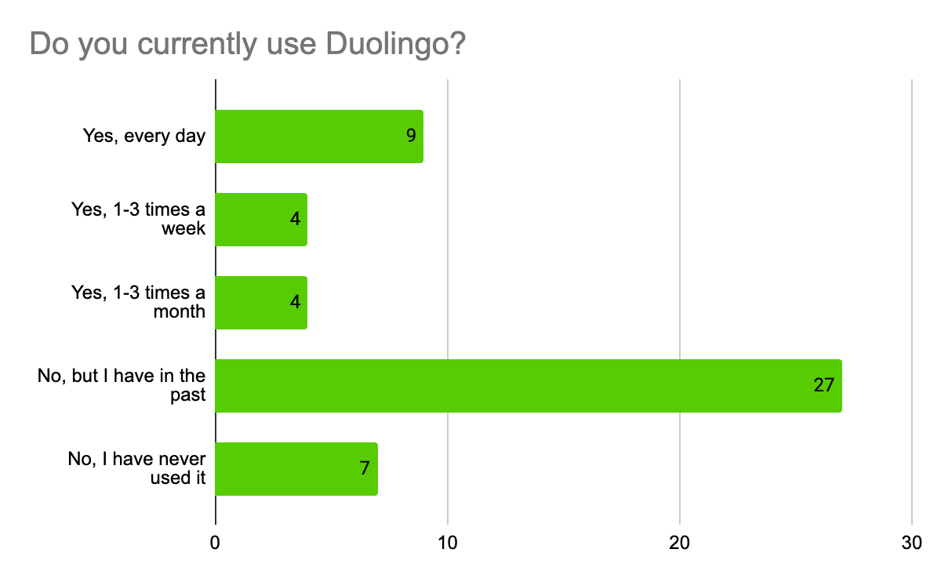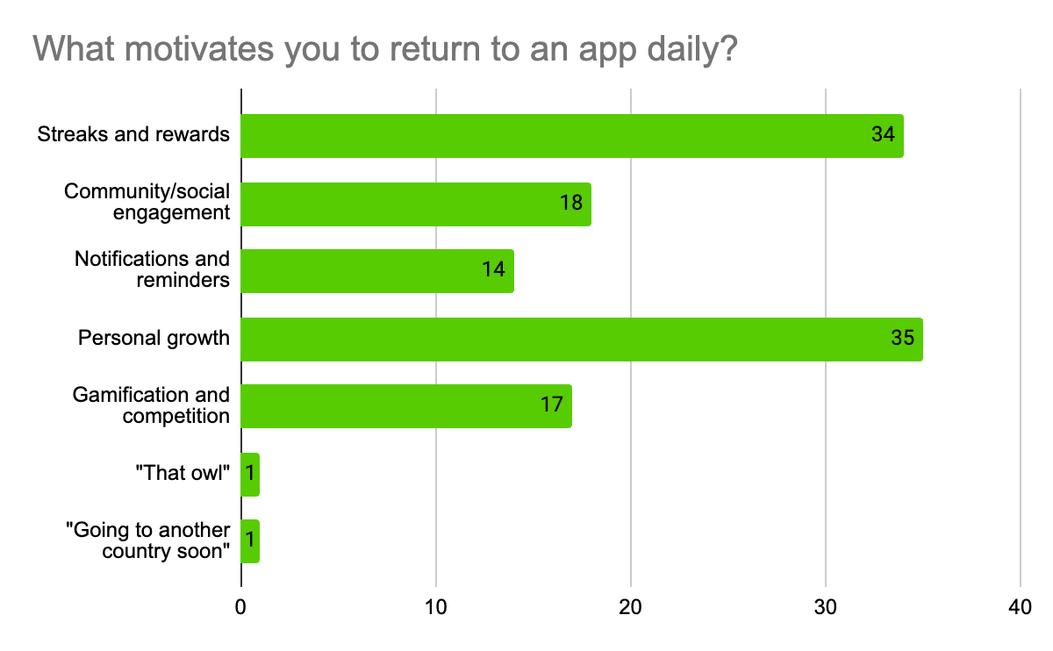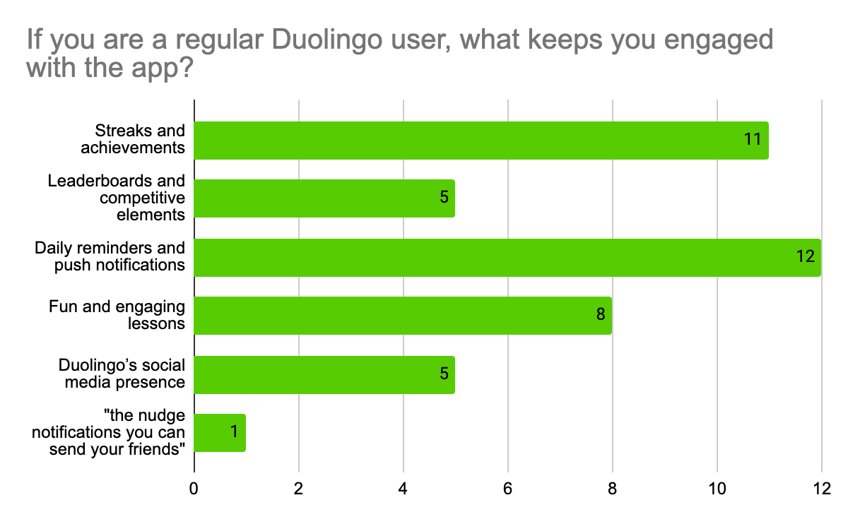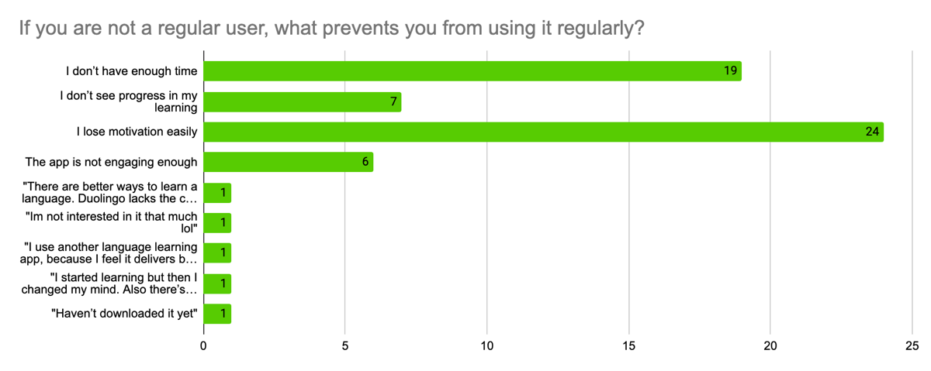

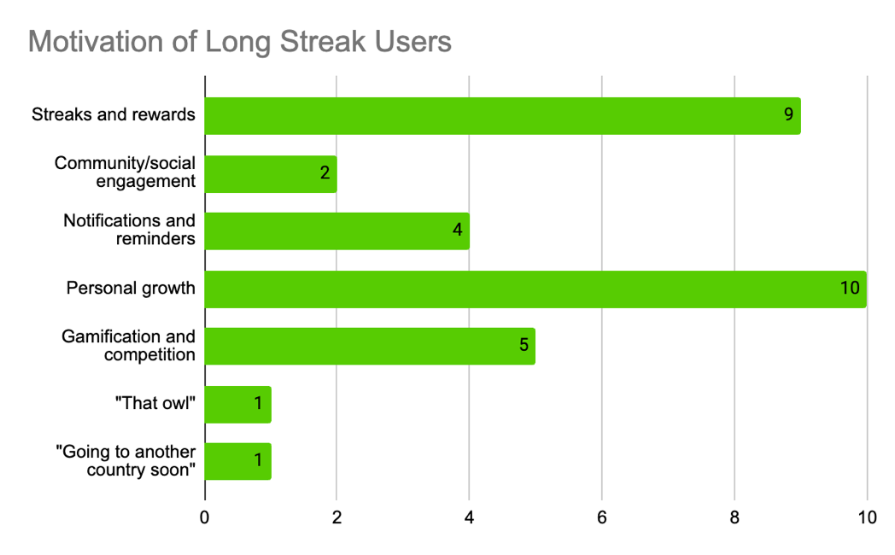

**Findings**

            The analysis concluded that most survey respondents do not currently use Duolingo. The mean streak length was 42.04, the median and mode were zero, and the standard deviation was 112.56. Out of 51 respondents, 34 stated that they have never used Duolingo or they have used it in the past but are not currently. The primary motivations for returning to an app daily were “streaks and rewards” and “personal growth.” This finding was consistent with long-streak users as well. Respondents who regularly use Duolingo expressed that “streaks and achievements” and “daily reminders and push notifications were the main factors that kept them engaged with the app. Respondents who don’t regularly use Duolingo expressed that a lack of time and motivation were the primary obstacles that kept them from becoming regular users. When analyzing the open-ended questions, the common themes that arose when asked, “In your opinion, what makes an app engaging enough to use every day?” were effective target marketing (“It has to cater to their core audience.”), personal motivation (“If I’m addicted.”), diverse content (“Something new everyday like tiktok’s fyp grabbing new content everyday. Also ppl’s personal feeds like on Instagram (feed & stories).”), entertainment (“If it’s created in a fun way.”), accuracy (“If it provides reliable information and is relatable. It will also help if there were more reinforcers.”), achievement (“Keeping a daily streak and seeing results from daily engagement.”), app format and accessibility (“Aesthetically pleasing and simple.”), and a social aspect (“When more people are using it and can collaborate with each other.”). When asked what respondents would change about Duolingo to improve their experiences, the primary changes that they wanted were fewer constant notifications (“It’s annoyingness and constant harassment with notifications.”), more paid features in the free version (“More lives.”), additional languages (“Maybe add some more languages that aren’t currently part of the app.”), but a majority of respondents said they wouldn’t change anything (“I honestly wouldn’t change anything.”). One respondent mentioned “wifi.”

            The interview analysis was consistent with my hypothesis and initial research that cue, routine, and reward play significant roles in users’ consistency with an app. The cue ranged from user to user, but the widget, notifications from friends, and midnight approaching were the primary drivers. Doing their Duolingo lessons was the leading indicator of routine; seeing their streak grow and receiving praise from the app and friends was the reward. Some other key themes that arose from the interviews were personal growth (“I mean, I would like to be able to speak languages a lot better and just kind of keep up with my knowledge so I don’t forget it. In case I travel or like, especially here, there’s a lot more people that speak Spanish, so I can use it a lot more.”), feeling disappointed if they missed a day or lost their streak (“Yeah, it would like, break my heart if I lost it. I put so much effort into it.”), app enhancements (“Maybe if they had, like, a feature where you could, like, find people that, like, speak the language that you’re trying to learn, like, sort of like match, match you up with with that person. So they practice English or whatever, and then you practice whatever language you’re trying to do.”), little to no interest in the leaderboard (“I don’t really care about those. Sometimes they like send notifications that like someone passed me. I don’t really care”), social media marketing (“Um, they changed like the profile or like the picture of the app icon, sometimes, based on like, what they’re posting. Like, they posted the thing that Duolingo was dead and then made him dead on the app. Yeah, so stuff like that. I think it’s funny, like, if you’re not on Twitter, seeing it like you don’t understand it. So it feels like an inside joke.”), and appreciated for the gamification of the app (“Um, I really like when there’s the like the game where you like tap the character around and then you have to talk to the other people in the level to figure something out, yeah I don’t know that one’s always my favorite so when I see it’s in the in that uh in that level I get excited to play it.”).

**Discussion & Implications**

            The main implication of the findings and research question, evident in the data, is that streak maintenance is the strongest driver of user retention. Those with long streaks are continuously using Duolingo not only to enhance their knowledge of the language but also to preserve their progress. This was clear in all three interviews and aligns with the behavioral theory of the habit loop proposed by Charles Duhigg. It was interesting to see how much of an emotional attachment users had to their streaks. They expressed strong negative feelings towards themselves if they were to miss a day of their lessons or lose their streak altogether. Users’ long streaks have become a part of their identity and an indicator that shows they can consistently achieve their goals. Their long streaks also come with bragging rights, as users are excited to show off their progress and receive recognition.

The cue-driven behaviors were the significant reinforcers that led users to complete their lessons. However, the most enticing cues were friend notifications, the home screen widget, and the clock approaching midnight. Users who had friends on the app who “nudged” them to complete their lesson for the day expressed that they paid more attention to these notifications than the automated ones from Duolingo. Additionally, those who added the Duolingo widget to their phone’s home screen were more inclined to tap on it. Although the computerized notifications weren’t as motivating as friend notifications, the reminder sent by Duolingo as the clock approached midnight significantly encouraged users to complete their lesson, reinforcing the finding that streak maintenance is key to user retention on Duolingo. That said, it is essential to acknowledge that personal motivations cannot be ignored. Users must want to learn a language to use the app. The survey data also supports these findings, as respondents expressed that “streaks and achievements,” “daily reminders and push notifications,” and “personal growth” were the primary drivers of engagement and retention. Users were fond of the gamified elements of the app and expressed that Duolingo’s approach to making learning a language fun makes them enjoy completing their lessons. However, all three interviewees mentioned not caring about the leaderboard. The leaderboard puts 10 to 15 users in competition to earn the most points in a week, but these users are random and not linked to the friends they have on the app. This shows that people still crave community and social interactions, even with an app like Duolingo, where personal growth is encouraged. Users do not feel connected to the leaderboard as it has no personalization.

Duolingo’s social media marketing also played a role in user engagement. Those who followed the brand’s social media efforts felt more connected to the app. Duolingo often incorporates the humor from their social posts into the app. For example, when the brand decided to kill off the owl mascot, Duo, they also changed the app’s icon to represent Duo’s passing by putting Xs over his eyes. One interviewee expressed that this connection makes her feel like part of an inside joke. So, the brand’s marketing efforts also motivate users to engage with the app. Lastly, all three interviewees and most survey respondents expressed that they’re looking for enhancements to Duolingo. Most of the upgrades mentioned were part of the paid Duolingo subscription, such as more hearts, better explanations when getting a question wrong, and more real-world practice with languages. This shows that users are deeply invested in improving their language knowledge and wish that the free app version provided them with better tools to achieve this. Survey respondents also mentioned that they want more languages offered on the app. Although Duolingo has many common and popular languages to learn, not including all the languages could limit the brand and decrease usage. Connecting to the research question, the data shows that high user retention is not caused by one single factor but a mixture of habit-building features, internal and external motivations, and the app’s design.

**Limitations & Future Research**

            The limitation I experienced when collecting the data was people’s hesitation to participate in the research. I did not have as many survey responses as I would have liked, but it was still enough to gather a good understanding of the findings. While for the interviews, only 3 out of 8 long-streak users I contacted answered the email.

            Future research on this topic and Duolingo could include adding more premium features to the free version, personalizing the leaderboard, and exploring new ways to support low-motivation users. Looking into how many more people would use Duolingo if there were more premium features in the free version could be an interesting study for the company. I hypothesize that Duolingo would gain more consistent users if it provided better language-learning tools in the free version. I also suggest that Duolingo research whether competing with friends increases engagement. Through the research, we can see that the social aspect of the app drives engagement so personalizing the leaderboard and making it a competition with friends could not only increase daily usage but also how much time users are spending on the app, as they would have to complete many lessons in a day to beat their friends. Lastly, Duolingo should research new ways to support low-motivation users. Some of my suggestions include providing a grace period for streaks within the first month or two and including quick and easy lessons for those who lack the time and motivation to use the app.

**Conclusion**

            The key takeaways from this research are that retention is habit-based, streaks are more than gamification, and an app’s design should enforce habit-building. Those who created the habit of using Duolingo daily could stick to it better than those who used the app casually. Streak maintenance was the most significant factor keeping users returning to the app. Users strongly identify with their streaks (“I am a person who practices every day.”). Streaks represent a commitment to users and make them feel better and more excited about achieving their goals. Finally, apps like Duolingo need to be designed for habit and not just fun. Cue, routine, and reward are a proven way to retain users, so this theory needs to be implemented to encourage engagement.

**References**

Ceci, L. (2024, November 18). *Duolingo: quarterly global MAUs 2020-2024*. Statista.

<https://www.statista.com/statistics/1309610/duolingo-quarterly-mau/>

Duhigg, C. (2014). *Power of Habit : Why We Do What We Do in Life and Business*. Random

House Trade Paperbacks. (Original work published 2012)

Duolingo. (2025). *About Us*. Duolingo. <https://www.duolingo.com/info>

Hamari, J., Koivisto, J., & Sarsa, H. (2014, March 10). *Does Gamification Work? -- A Literature Review of Empirical Studies on Gamification - IEEE Conference Publication*. Ieee.org. <https://ieeexplore.ieee.org/document/6758978>

Vogels, E. A., Gelles-Watnick, R., & Massarat, N. (2022). *Teens, social media and technology*

*2022*. Pew Research Center. <https://www.pewresearch.org/internet/2022/08/10/teens-social-media-and-technology-2022/>

**Appendix A**

**Survey Questions**

**Appendix B**

**Interview Questions**

1. How long have you been using Duolingo?
2. What language(s) are you currently learning on Duolingo?
3. What motivated you to start using Duolingo?
4. How many days is your current streak?
5. Have you ever lost and restarted your streak?
6. What keeps you coming back daily?
7. Do you have any specific goals you’re working towards with Duolingo?
8. Have you ever felt like quitting? If so, what made you continue?
9. What time of the day do you complete your daily lesson? (Morning, afternoon, evening, etc.)
10. Do you complete just one lesson a day to keep your streak or many lessons?
11. Do notifications motivate you to complete your daily lesson?
12. Do you have any external motivations to keep up your streak?
13. How do you feel about Duolingo’s gamification features, such as leaderboards and achievements?
14. Which gamification element do you find most motivating, and why?
15. Do you pay attention to your placement in the Duolingo leagues? If so, how do they affect your engagement and motivation?
16. How do you feel when you miss a day of lessons?
17. Do you use the social features, such as friend challenges?
18. Have there been any times you struggled to keep your streak? If so, what were the reasons and what motivated you to continue?
19. What do you think Duolingo could do to make the app more engaging for new users or users with short streaks?
20. What advice would you give to new users trying to maintain their streaks?
21. Do you believe maintaining a long streak is worth it and has contributed to your language knowledge?
22. Do you have any additional comments or thoughts?

**Appendix C**

**Interview Transcripts**

Interview 1:

Okay, so how long have you been using Duolingo,

um, like, years or like, um, like, the number on du lingo, both, um, probably, I probably had it downloaded for, like, like, probably, like, six, maybe. And then my number on Duolingo is 468,

right now. Very impressive.

Um, what languages are you learning? Or I'm

doing French and Spanish, French, which I took in high school. So I'm just like doing that one to like, like, keep it up basically. And then Spanish, which I am just trying to, like do

so you didn't have any prior Spanish experience before starting Duolingo. No, um, how do you think your Spanish, Spanish knowledge has been with Duolingo versus, like, your French College, which you already knew some before.

Um, I think it's okay for, like, basic stuff and, like reading. But I I think hearing it from like, people that are actually speaking Spanish is kind of different, like, actually, like a couple, like, maybe, like, a month or two ago, I was like, getting my friends, like, Uber Eats order, and the guy, like, didn't speak he he spoke Spanish. And, like, we only got one cup, and it was supposed to be three. And so I was on the phone. I was like, Oh, perfect. Like, I can bust out my Spanish. But like, I was trying to talk to him, I could not think of a single thing to say. And I was like, oh, man, even though I had like the 400 like days on du lingo, and I couldn't even be like, Oh yeah, like, we're missing two cups of

whatever, yeah. So do you think you can speak better French because you have that, like, prior knowledge, not on du lingo? Yeah? Okay, um, so what motivated you to start using through lingo? Um,

yeah, so for French, we started, like,

I think in like, eighth grade or something. So then once I graduated high school, I wanted to, like, keep it up, like, because it's on, like, my, like, LinkedIn, resume, whatever, like, just have something like that to have, and then Spanish. I, um, I watch, like, a lot of 90 day fiance and I don't know that a lot of them speak Spanish, so I just was kind of like, oh, I should, like, learn Spanish because I'm watching this show. And, like, they're always, like, arguing and stuff. But yeah, it wasn't like, yeah,

did you start using Duolingo for French after you finished your classes, or, like, during class? Yeah,

after graduating high school, when I didn't have like, French class anymore, because I wasn't going to take it, like, here or whatever, so I just started, like, locking into the du lingo, I guess, yeah, try, yeah.

So, when you started French, did you start from the beginning of, like, did you start with, like, the basic, like, Apple?

No, they had, like, a placement test. And I took the placement test, and then I just went from, from there.

Have you ever lost your streak? Um, yeah. Um, do you remember how long it was when you lost it? Um, so what keeps you coming back to the app daily?

Um, for French, just to, like, make sure that I have, like, at least basic, like, at least I can keep up where I ended off in from high school. And then for Spanish, just to, like, try to learn another, have another language, like, just in my knowledge, I guess

so. Learning languages is very important to you. It seems,

um, are there any specific goals you're working on?

Um, I'd like to be able to have, like, in Spanish specifically, like, like, a conversation, like, so if, like, the Uber thing, again, like, I would like to have been able to, like, explain what the problem was, and then, like, converse with the guy, yeah.

Um, have you ever felt like quitting, and if so, what made you continue? Um,

I guess, like, before I had, like, this, the streak like that I have now I, like, wasn't going I wasn't doing it like every day. It was kind of like once in a while when I thought of it, but like now with the streak, like, I

don't know, I think it's cool to see the number. Yeah.

So what motivated you to become a regular user, since you said, like, for a while, you were just doing it every once in a while? What was. The motivation between that switch, yeah, so

the one I was doing every once in a while was the French, and then when I added the Spanish to for because of the show, that's when I, like, had the streak, okay?

So it was like learning a completely new language, yeah,

when you were doing it, just occasionally,

do you,

I mean, I guess it was probably a while ago, but do you remember why? Like, you wouldn't do it every day, or just

because I was, at that point, I was just doing French, so I thought it was more like, like, I'm just doing it to keep up. So, like, as long as I check in every once in a while and know that I still know like this and this and this, like, I'm like, Fine, like, with, like, learning something, like, completely different. I mean, obviously, like, I guess people know, like, like, Ola from, just like, walking around, like, maybe up to 10, like, just like, from just knowing, but like, it was like, starting, like, from like zero and just like, having to, like, build the knowledge basically.

Um, to what time of day do you usually do your lesson? Like, morning, afternoon, evening?

Um, usually do it either on the train or at night, like before bed. So Morning or night,

okay? And for like, morning, would you say you're reminded by the notifications, or do you just, like, find yourself having some free time and they're like, oh, I should do it

now. Yeah, just like having the extra time, like sitting on the train and, oh, I could do it right now and

then, for evening or night, is it just to, like, keep up the streak, or, yeah, evening,

usually it's I forget. And then I have, because you can set like, what time it reminds you, and I just, like, have it set to like my like, bedtime frame. And then I'll be like, oh, right, I forgot. And then I'll do it. Then

when you complete your lesson, do you do just the one daily lesson to keep, or do you do a couple?

Um, usually just one, okay.

Um, do the notifications motivate you to complete the lessons?

Um, I only get them at night when I'm like, when it says you're about to lose the streak. So, yes, okay.

Do you have any external motivations, like not coming from the actual app that help you,

I guess, just like wanting to, like, know the languages,

um, are you familiar with like, duos, gamification features like the leaderboards and the achievements? Yeah, um, how do you feel about them?

I don't really care about those. Sometimes they like send notifications that like someone passed me. I don't

really care. So you don't really interact with them. You just do that. Okay, do you do the friend streaks or like well, I guess this next question doesn't really pertain as much. I so if you, because I know the dualingo offers streak freezes when if you have missed a day, or whenever you do miss a day, how do you feel?

Um,

I guess it's like, kind of disappointing, especially like with the number, like, being, like, bigger at this point, it's like, oh man. Like, I could have to start over. Like, usually the streak freeze. Like, will, like, save it

if you were to lose your streak, like, completely, and you will not offer any street freeze. Do you think you'd give up, or do you think you'd restart? Um,

I think I'd restart. Um,

have there been any times that you struggled to keep your streak?

Um, yeah, probably like, over, like, breaks and stuff when I'm not, like, in school and I'm more so, like, just, you know, walking around or whatever, like, because I'm not thinking about, like, learning in general. So I don't usually, like, remember the du lingo until, like the nighttime, like notification, like I mentioned before.

So you say that, like being in your routine helps you do your work. Um, so when you were struggling to keep your. Greek, what were the reasons that you continued, or what motivated you to continue? Well, you kind of said the notification at the end of the day, but what is it about that notification? Specifically, like, you get the notification, but like, what actually makes you? What do you think logically, it makes you click on the app actually do it,

probably at this point, just like, having, like, the number be bigger, because, like, before I, like, I wasn't, like, consistently doing it, and now I'm, like, consistently doing it. So it, I don't know. I guess it's just like, it's like shows, like, you know, like, I don't know, maybe, like, determination or something,

um, what do you think Duolingo could do to make the more engage, the app more engaging for new users or users With short streaks.

You could think on it. Yeah, I

if it helps. It's kind of like, think back to when you were first starting like what would have helped you? What would have made you stay on the app more come back to the app more often.

Um,

maybe if they had, like, a feature where you could, like, find people that, like, speak the language that you're trying to learn, like, sort of like match, match you up with with that person. So they practice English or whatever, and then you practice whatever language you're trying to do. Okay, like, I had another app that did that exact thing, like, that was its whole thing, like, that's kind of, like, I don't know, like, creepy, because you don't really know these people. It's like, it was, like, full like, faces and everything, like on Duolingo could just be like, little cartoon characters that they give you, and, like, not be like crazy, like, random person in like, Spain or something,

yeah, um, do you just use the free version of Duolingo? Yeah. Have you ever used the super du lingo or du lingo Max?

Um, just when I got like, the free like trials that they give out some time?

Um, what would make you purchase the legal subscription.

Um, if they, like, expanded, like, their services, I guess, like, if they made it more so that you could, like, actually learn, and it's not just, like, basic things, like, then I might consider it. But like, I don't know. I don't think it's doing that much, at least for Spanish, which I'm, like, learning from the bottom, like, French is, I can't really tell, I guess, because, like, I already knew some so, like, that one just keeping up. So I don't know. Maybe they're better for that. But, like, for Spanish, like starting out, like, if they made it more so that, like, after having like, 400 days, you could, like, tell someone that speaks Spanish that they like forgot your order, right, and not have to, like, have like, Google Translate.

What advice would you give to new users, users trying to maintain their streaks? Um,

probably to, like, do the lesson earlier in the day and not wait till night time when it's about to, like, reset, or like, about to, like,

end the day, or whatever, just so that you

make it like a routine, but like, something that you're doing not because it's like, about to run out, but because you're like, trying to, like, take in the information. Because if you're trying to do it and there's like, two minutes left in the day, you're probably just like going fast and not like retaining

so just kind of going back to that initial goal of wanting to learn a language, um, do you believe that maintaining the long streak is worth it, and has it contributed to your knowledge of the language?

Um,

I mean for Spanish, I think I definitely knew more than than when I started. So, like, it's helped in that way. But like, Yeah, I mean, if it, if it went like deeper, like I said, like, if it was more like in depth and got more into like, things that you would be talking about, it'd be better. But like,

yeah, having, like, the long streak is like,

good, I guess,

um So, Duolingo has a very, like, long process, or not process, but, like, has a very long learning course, like I it would. Probably take many years to get through the whole thing.

So do you think

so I personally haven't gone through the whole thing, or I don't know anyone that has, but it is possible to go through the whole thing, you're definitely gonna learn a lot more, because it becomes, like, more complex and like, has you completing like, critical thinking at towards the end? So do you think the beginning could be less like when you're starting a language from the very beginning? You don't know anything. I

don't know how to phrase this. Um,

because I know that. I know a lot of people like, say, like, it's hard to, like, actually learn the language. But I've, I've been told that if you do, like, keep up with for like, years, it would it is possible. So do you think it's better if maybe, like, the easier things are, like, reviewed a little faster, so that you get to, like, harder things, so that you actually feel like you're learning the language.

Yeah, yeah. I think they could do some like condensing of, like, the the levels, I think for um first for Spanish, I'm like, on um, 13. I don't know what it goes I think it goes to like, oh yeah. It goes to 160 so I'm on 13, but it's like, yeah. So like, I imagine, like, when you get further, you're, you're gonna know more. But like, right now I'm, like, describing your family, and I feel like that could be, that could have been earlier. Um, I

think that's everything I had. Do you have any additional comments or thoughts specifically on like user retention and trying to stay longer on the app, or getting more users to keep up their streaks or start a streak.

Um, not really. Okay.

Well, thank you for your time. I really appreciate it. Thank you. Sorry for missing the first time. Oh no, it's okay. No worries. Okay, Zoom's in my lifetime too.

Okay. Have a good one you.

Interview 2:

So you've mentioned in your survey that you have a very long Duolingo streak, which is very impressive. Thank you. How long have you been using Duolingo

since last March? Okay, so just like how long the streak has been? Yeah, pretty much I haven't lost my streak since I started. So

that's great. Um, what languages are you learning? I'm

learning in Spanish mainly, and then also French,

okay, is there what like? What is motivating you to learn these specific languages?

I did Spanish in high school and got, like, a lot of college credit for it, but my teacher was white, and, like, spent a semester in Peru, and that's why she's teaching it. So I was like, Oh, maybe I should just continue to learn because I couldn't speak it very well, but, and then also, I just thought it'd be fun to learn French. So

what? Why did you start using Duolingo?

Um, I had used it in the past when I was younger, but never, like, stuck with it, and then I had been seeing, like, more tweets and stuff about Duolingo, and my friend and I both decided, let's start to do a lingo streak. And that was that,

um, so you said you've used it in the past. What do you think like made the difference for you to stick with it the most recent time you started, versus other times?

I think because when I would use in the past, like, I was already in like a language class, so it kind of seemed irrelevant because I was learning different stuff in class and on the app, and then also, like, I wasn't on social media as much, or, like Twitter, especially when I was using, like, middle school and early High School. And so I mean, there wasn't like, funny stuff really, either. That Duolingo would incorporate that, like, kept me going.

So you would say, like, their social media efforts have definitely made an impact on you. Yeah,

like them in social media, and then they'll also incorporate that, like in the app. So it's kind of like inside jokes sometimes, yeah, I like it. I think it's funny.

Um, how do you think they incorporated it in the app?

Um, they changed like the profile or like the picture of the app icon, sometimes, based on like, what they're posting. Like, they posted the thing that Duolingo was dead and then made him dead on the app. Yeah, so stuff like that. I think it's funny, like, if you're not on Twitter, seeing it like you don't understand it. So it feels like an inside joke.

How long is your strike right now? Um,

let me look i

403 nice. And

you said you've never lost it before. What

do you think keeps you coming back? Haley,

the idea of having such a long streak? Yeah, it would like, break my heart if I lost it. I put so much effort into it.

Have you ever missed a day or, like, got used the streak freeze?

Yeah, I've definitely used, like, a streak freeze, at least, like, once every other month or something. Just sometimes I forget, but I'm glad that they at least have those.

Yeah. How does it make you feel when you're missing it? I feel

bad because then I don't get, like, a perfect week or a perfect month, yeah? And I like when I get those, because then, like, all my friends on Duolingo get a notification and they can High five me. It makes me feel cool. So I don't like using my street phrases.

Do you have any specific goals you're working on with Duolingo?

I mean, I would like to be able to speak languages a lot better and just kind of keep up with my knowledge so I don't forget it. In case I travel or like, especially here, there's a lot more people that speak Spanish, so I can use it a lot more.

So learning languages are like, continuing to learn is something very important to you. When you think you're going to keep doing it like for rest

of your life. I think it's very useful, especially because what I want to go into, it's like environmental justice. So a lot of it has to do with, like South and West Chicago, where there aren't as many just straight English speakers. So I think it's very useful. Yeah,

um, have you ever felt

like quitting? If so, what made you continue? I.

Um, towards the beginning, I felt like quitting because my friend that I started with stopped. Oh, well, that's not just fun, but I continued just because I thought it was really impressive. And like, anytime I tell people what my streak is, like, I feel really proud of myself and really cool. So, yeah,

um, around, like, what time did your friend wait? Like, how long was your streak?

Probably, like, three weeks. So, like, 21 days. So do

you think that, like, was enough for you to be like, Okay, I should continue this, or was there any other things motivating you?

I mean, like, Yeah, I'd made it almost a month. Some of my other friends had started using Duolingo. My mom was using it for a while, and then my brother as well. And so there's, like, a friend streak option too. So I didn't want to, like, lose my friend streaks, or they were friend quests. So, yeah, I also just wanted to, like, beat my brother and have a better streak than him. So, so

you've definitely, like, built some type of community around Duolingo.

Yeah, it's definitely, like, a thing that my friends and I talk about all the time. Not all of them do it still, but every once in a while, one of them will, like, stir back up again. And I'm like, yes,

what time of day do you usually complete your

lesson? Usually

at night when I get the notification that I'm gonna lose my streak.

So

why do you think? Well, I mean, it's pretty obvious, but why do you think that like the night notification motivates you more than like the morning or afternoon once

it's usually because, like when it comes out at night, I'm in bed already or something or just on my phone, compared to like when they are in the morning or the afternoon, I'm in the middle doing something, or it gets lost in my other notifications, so I don't really see it, but at night, like, I see it on my phone, and if you, like, wait too late, there's also a countdown that, like, stays on your home, like your lock screen. So that's usually why, um,

do you usually do just one lesson to, like, keep up with the streak, or, like, multiple a day.

I usually just do one. It depends if it's on at like, the beginning of the end of the month, because there's like, monthly challenges too. So if I want to meet like, that monthly goal, to get the badge, then I'll probably do like, two or three, depending on, like, how many I need to get the quest on.

Would you consider, like, incorporating it

more into your morning routine? I mean, I don't know how like hectic your morning routine is time, but you have time. Would you consider incorporating it? Yeah, when

I I work at like, a desk on campus, so when I work, like, six to 10am and there's nothing else to do. I usually do my Duolingo then, but those just aren't as frequent as like me doing them as night at night,

okay, but yeah, I feel like

waking up. If I wake up earlier and have more downtime and is less hectic, then I definitely do it more to get out of the way.

Um, times you do it, like, earlier in the day or, like during your job. Do you just, like, remember on your own, or is it a notification that reminds you?

Sometimes it's a notification. I have, like, a widget on my home screen too, so I'll see that and be like, okay, um,

how do you feel the notifications motivate you. Like, do you think they do? Do get discouraged when, like, duo gets sad because you haven't come to the app?

Um, sometimes they're like, threatening, yeah, that kind of motivates me. Other times, if you have like, a friend streak, you can nudge your friend to do it. So if I see like, my brother nudge me, or my roommate nudge me. I'm like, oh, I need to do it so that they stop annoying me.

Um, do you think that's like, more effective, like, the getting a notification, specifically from like, someone else, versus just the app?

Definitely, because they have to, like, actually press the button to send me a notification. Just like, oh, they actually want me to do it, compared to, like, an automatic notification.

Are there any external motivations that make you like, want to keep your streak, um, other than like friends, because I know we've mentioned that, yeah, um,

I guess just like my own, I just kind of want to keep it because it's been going in so long, but that's pretty much it. If you were to lose

your current streak right now, like you couldn't get it back, like no more street freezes, would you restart? Um,

maybe. I.

I feel like I probably would at least take a break or something, but I would want to restart. That's for sure. It's just a matter of if I do or not. Yeah.

Um, how do you feel about duolingo's Like gamification features, like the leaderboard achievements.

Um, the leaderboard. I'm not like, a huge, huge fan of just because it's like, cool for people that do, like, multiple lessons a day, but I don't. And so I used to get, like, high on the leaderboard when I first started doing it, because I would do it more often. And now I'm, like, always going back and back. And it's not like a huge thing for me. I kind of ignore it.

What about like the friend ones, or like the monthly challenges, or weekly challenges.

I like those just because you can, like, high five your friends. I like getting those kind of things. I think that's cool that my friends are seeing what I'm doing and what I can see that they're what they're doing. And I also I just have a thing with, like, any game I play, if there's like, a monthly or a daily challenge or something like I want to complete it.

Um, so do you think like the challenges motivate you more? Yeah, out of like all the gamification features, which one do you find almost motivating?

Probably the monthly challenges. Okay, why do you think that is just because you get, like, a badge on your profile, and it feels cool to be like, Yeah, I got these badges the past however many months.

What would you say those badges like represent for you?

Um, I guess they're kind of, like, my own badges, or like medals or something. They're saying, like, yeah, you completed this, and that's impressive. And, yeah, um,

so you say you don't really pay attention to, like, your placement in the leaderboards. No, what do you think would make you pay more attention to it?

Um,

I think like if I did more lessons a day, um, or if there were, like, bigger prizes, I guess because, like, sometimes when you get just like regular prizes during your lessons, every once a while, you'll get, like, a free three day like super subscription, like family super subscription. So like, if they could do that for getting the top of the leaderboard or something, instead of just gems.

Um, have there been any times where you've struggled to keep your streak?

Yeah, there was this one lesson that I kept getting stuck on, and I didn't realize that I could keep my streak just by, like, doing lessons to get more hearts so I kept, like, running out of hearts, and then I wouldn't be able to do my lesson because I didn't have hearts to do it. And I didn't realize I could just go and get more hearts so that I had to use, like, two breezes in a row because I couldn't get past this lesson.

Um, what do you think are the reasons that you continue, or what motivated you to continue because you've hit like, a pretty big roadblock.

I mean, it just frustrated me, and so at that point, like, I wanted to complete it. Yeah, it was, like, one of those lessons that was, it wasn't even part of the lesson. It was like, working on things that you're not good at. So kind of like working out those things and just like, oh, they think I'm bad at this already. Like, I just need to finish it so that I can get over this and not do it anymore. It, I kind of viewed it as like a hurdle, and just had to finish it to keep going on. So you like

the challenge? Yeah. Um, what do you think Duolingo could do to make their app more engaging, or also, like, retain new users longer,

um, I think like moving the way that they do social media, like, it's mostly just on Twitter. Like, the most that I see, anyways, is on Twitter. They always like, tweet funny stuff and like, kind of a Gen Z humor. So I feel like if they moved and did a lot more of that on like Instagram, they do some Tiktok stuff, which I'll get every once a while, but definitely more like they're pretty good with their

social media, though, I guess

I don't know.

Okay, no worries. Um, what advice do you think you'd give to people like just starting out or trying to maintain their streaks?

Um, I would say,

just keep going and just do the one lesson. It's doesn't have to be that serious. Duolingo, it. Isn't a fantastic way to learn a new language, just because it the lessons are usually very repetitive. I've done like, the same lessons, probably like, five times now, with, like, slightly harder things, but it's fun to just do it and then keep a streak, and eventually you can, like, tell progress.

So do you think that maintaining the long streak is worth it, and has it contributed to your language knowledge? I think

definitely having, like, a longer streak and doing a lot more I have gotten better knowledge, or definitely refreshed. But if you're looking to do it, like learn a new language a lot faster, that it's not really the way to do it,

um. So I have one more question.

So a lot of research has shown that keeping users on an app or just continually, continuously doing something is made up of a cue routine and a reward. Um, would you like me to explain those? But I feel like they're kind of Yes. Um, so basically, like your cue is something motivating you to do it, maybe a reminder, or your friend, or just you remember on your own routine as you doing it consistently, and then reward many different things depending on what like the routine is. So what do you think your cue routine and reward are with Duolingo

cue would be definitely like the my the notifications that I get at night or friends and routine, I guess, is like doing it at night as well, so just kind of doing it before bed, because I always see the widget too. And the reward is being able to add another day to my streak and like work towards those, like, friend challenges or something. And I just like having the extra date of my streak, because the more that, the longer streaks you get. You get, like, more notifications on your friends side, like they always see it, or you get like extra gems and stuff like every 25 days, I think so,

when you get like notifications,

notifications, but when you finish your lesson for the day, and it like, you know, switches to like, one more day, and you see that like little animation, or like you're doing however many correct in a row, and it says, like 10 you Did the last 10 in a row? Like, yeah, how do you feel? I see those. Do they encourage you? Do they evoke any emotional responses? They

definitely encourage me. Um, the sound that it makes when you get like, five in a row, 10 in a row, it's just like a really good sound. I really like it. It also like vibrates your phone in a fun way. So I kind of really like that. But there's also, like, cool animations. When you add another day to your streak, if you get like, a milestone, it always gives you the option to share it with someone. So it Yeah, it really motivates me, and it makes me, like, feel happy. Like, Yeah, I'm good at this. I'm doing good.

What made you, um, decide

to add the widget to your screen.

Like, help me remind myself. Um, that was the main reason. And then at this point, like, the later it gets in the day, like, the more mad the Duolingo on the widget gets. And I think it's really funny. So and sometimes, like, the things they do on Twitter and then implement the app also show up on the widget. So it's kind of fun to see.

Do you have a lot of widgets, or is this your only one?

I have, like, two widgets, but they cycle through things, okay,

um, that's all I have. Do you have any additional comments or thoughts.

Okay, sounds good? Well, thank you for your time.

Yeah, thank you,

bye, bye. Have a good one. You too.

Interview 3:

So how was your day?

Hmm, my day's been all right. It's just been a little busy and you know, it's still cold out, even though it's the middle of April when this time last year we were wearing t-shirts, so.

Yeah.

It's a bit of a bummer, but it's all right. I'm telling you, these phone calls are crazy. Yeah. How has your day been so far?

Very good. I took a nap that went way longer than I should have, but.

I mean, it's just making up for the rest that you were needing, you know?

You know, so I'll get started. Um, so how long have you been using Duolingo?

Um, I am on, I have a 69 day streak. So I used it, um, a little bit before, but this is the first time where I'm like super consistent with it.

Um, I am on, I have a 69 day streak. So I used it, um, a little bit before, but this is the first time where I'm like super consistent with it.

What languages are you learning?

Uh, I'm just learning French.

Okay. Is there a significance for French?

Yeah, in June I'm going to a study abroad course in France, so I wanted to have a little bit of knowledge before I went, so I wasn't just like completely lost. Even though I know in a lot of European countries they speak English now, it's just a good skill to have.

So that's what like originally motivated you to start using Duolingo and good sam. Yeah. Have you ever lost and restarted your streak?

No I've been keeping it strong. That's good.

What do you think keeps you coming back daily to the app and maintaining your streak?

I think because the number is like on the higher end it would make me kind of like disappointed in myself if I just let it um and because it really takes like two minutes to do a lesson so I haven't been on like the grind that I was on before like doing multiple lessons a day I only do one a day so then I um so then I keep my streak going

So what change do you think, Brown, you do like multiple lessons to just want to keep your street going?

And I think one factor is like the hearts that are involved. Like if I get a perfect lesson that I could keep going but if I was on down to like two or one hearts I wouldn't want to risk it and then like do a lesson halfway through and then lose all my progress because it would just kind of feel like a waste of time.

So if you do a perfect lesson, do you still continue? Even like when you're rehearsed or full?

Most of the time, no, but sometimes if there's those daily objectives, if it's complete two lessons, then I'll just do it because I'm already here.

Why do you think that is, since you were doing multiple lessons before, what kind of changed?

Hmm. I think in the beginning it was kind of like dopamine hits with like the sound and like all the the colors and like congratulating me and it was really easy early on.

I mean it's still pretty easy but it's more like I have to type it out now and listen and talk. That's another thing like I don't like to do the talking when there's people around me because I butcher it so bad and I know I can like skip over that but I want to practice my skills as much as I can so usually when I end up doing my lessons it's like the first thing I do when I wake up or like the last thing I do before I go to bed just to like either get it over with or like make sure I catch it right before the streak dies.

Yeah, I'll kind of come back to that point a little bit later. Do you have any specific goals you're working towards with Duolingo?

Um, I guess for the, the first goal I have is to reach a hundred days, since it's not too far off in the distance. Um, I think I know somebody that has like over a thousand days, which is crazy.

I don't know if, I don't know if I'll keep doing dual lingo after I come back from my trip just because I don't know if I will really need it anymore, but who knows maybe it'll like motivate me to get the family plan and like do a hundred lessons a day or something.

Yeah. Sorry, I kind of lost track of what it was. Have you ever felt like quitting? And if so, what made you continue?

Um, I've had like thoughts of like, Oh, maybe I'll just let it go past this one day, but when you get closer to the end of the day, you know, you get that big pop-up on your phone and it's like times running out and then it really is just like two minutes and that's what I like put into perspective. It's like whether or not I do the dual lingo, the two minutes are going to pass regardless, so might as well like do something that's a little bit more efficient with my time than just like keep going on Instagram reels.

What do you think more of it in that perspective, because I say most people would choose the Instagram wheels.

Um, I've been on like this journey. That's so corny, but like, I've been trying to shift my perspective on things. Um, but yeah, I don't know, just hearing like a quote where it's like, whether you start now or start a year from now, like the time's going to pass regardless. So just, um, it's helped with like doing things that are more like, uh, what's the word, just like better for my brain.

It's like trying to read more, trying to practice a language, trying to do more like creative things, cause I could be just on Instagram reels, but it's just like brain rot, so it's kind of like in a way. Like self-help, self-care. Yeah. I haven't really thought about like that before. It's making me think.

Yeah, definitely good that you have that motivation for like self improvement. Um, what time of day do you complete your lessons?

I know you said usually in the morning or evening, what, like if you're doing the morning, what made you do in the morning? And then I know usually in the evening it's because you want to keep the streak.

Um, in the, if I do it in the morning, it will usually be around like 7 30 or 7 45. Cause my phone is just like right by my, right by my head. So then it's like a way to wake me up right away.

Cause I kind of have to think a little bit. And again, it goes back to like, I could be on Instagram reels right when I wake up, but by doing that, I've noticed it like kind of wakes me up more. And motivates me to like start my day off. Then like just being on my phone and my bed.

Well, the days you don't do it in the morning, why do you think that is?

It's usually because I'm running late, so I can't focus on doing the dual lingo. Sometimes I'll do it on the train or the bus, but I usually prefer to do it at my house, but there have been a couple of times where I've done it on the go.

Um, sorry, I just kind of lost my train of thought. Thank you. I have a question, a follow-up question, but I'm completely forgot.

Oh, we'll come back to you. What made you want to do Duolingo like what was the inspiration behind that.

Um, I just really like Duolingo and like their social media because originally I had my research question was also focused on like their social media efforts, but I kind of just got it down to like user retention because it would be easier to search that. But yeah, and I've also just been using it for like forever.

what's your streak? I have to check.

344.

Dang, almost a year excited. What language are you learning? French. Oh.

Oh yeah, so did you start French like from scratch or did you have any previous knowledge?

Um, I started it from scratch when I did Duolingo, maybe like a year ago, I was trying to refresh my Polish, but I understand it perfectly. So I felt like I wasn't really learning anything.

Cause I just already knew it. So I kind of just scrap that. Like, I don't really feel like I needed to practice speaking it or, you know, yeah. French was completely like, I've never even attempted French before.

Um, so back to like the time of day that you do it, um, Oh my God, I lost it again. It was like, okay, I was going to keep going.

So, um, do you think the notifications motivate you to complete your lessons?

I would say, I would say yes, especially that like big one towards the end of the night. That's when I know I'm really running out of time, but I think the notifications where you have a friend streak, where they complete it, and then it's like, you're really going to let her streak die.

Like, Oh, I guess not. But I would say so because I feel like if I didn't have the notifications or like the widget on my screen, like I would forget about the app.

Um, so you say you have the widget, what, why did you add that to your home screen?

I just knew myself like if I kept seeing the just the notifications, I would have gotten like, pissed off at them and like, just like cleared them away, or turn them off but I like the, the designs that are in the widget. Yeah. If you don't do it and then after you do it so I just like seeing what the dual L is up to. And it gives my home screen like a little bit more character. You know,

Um, so do you, when you do it in the morning, do you usually get a notification or like you'll open your phone and there'll be a notification or is it just like, you know, you should do it right now.

Um it's more of like that I should just do it right now. Um I have a friend streak with someone that usually completes their lesson at like one in the morning so they're really early with it. So sometimes I'll see that but majority of the time it's just like instinct to go and just start it off.

So how do you think that became like instinct for you? Because, you know, at the time, at the time you weren't doing that and what changed for that to just be like a normal routine for you.

I mean, I guess, just noticing the difference between what I did in the morning and when I didn't do it in the morning, because it felt like when I did it in the morning, like, like I said before, it like kind of woke me up more. But it also kind of got like one thing that I needed to do out of the way.

But I wasn't worrying about it. Because that's something that does worry me sometimes when I'm like, when I haven't done it yet, and it's getting late, and then I don't see myself going home yet. So just kind of having it all ready done with, I think I like that.

Do you think there's any external motivations that are helping you keep your streak?

I mean, I've like heard, uh, French songs and like just heard things in French where it's like, I can't recognize most of it, but then I'll recognize a word. I'm like, Oh my God, I actually did learn something.

So then kind of having that like reassurance that, um, that I actually am learning, because sometimes I feel like I can't really tell if this is actually like doing anything or if it's more of like a game learning, but kind of like seeing it play out in real life makes me want to keep doing it too.

So yeah, I do feel like you're actually learning the language.

I would say so. My best friend is like crazy with Duolingo. She's always on it and like she's learning like five different languages. But she's like, it's really not that good for learning any languages because you can't have a conversation with them, which I think is fair.

So I think in my situation, it works good since I'm just using it to like, hopefully get around places. But I think for like really trying to get into a language, it takes a little bit more. I think it's a good stepping stone. But like, think like watching, let's say like French movies or listening to French music would help more. And then obviously having a conversation with somebody in French.

Um, do you, how do you feel about the dual angle like gamification features like the leaderboards of the achievements?

At first I was motivated to be on top, but then, but now when it just says I keep getting demoted, I'm like, I don't really care because I just want to get my one lesson per day, just to be consistent with it.

Why do you think you don't care anymore?

Mm. It's just like too much work. Like, it's just like, I'm not like that competitive with it anymore. Just, I don't know, it doesn't really mean anything to me.

Yeah, why do you think it did mean something to you in the beginning?

Same thing with like the dopamine, like it's something new and I'm like I'm on top and it was like very rewarding and then as I started losing like, I don't know, just over time like the charm of it just kind of wore off on me. I'm like, whatever.

Um, yeah. So it seems like you definitely had like this like fun, fresh app and you were like, really, you really liked it. And now it's like, you know, the, the initial motivation is kind of wearing off, but you're still keeping your streak.

So why do you think that is since like, you're not as like excited by it anymore.

I think if I didn't have this study abroad course coming up, like I think I would have not been using it anymore. So just having that motivation keeps me going.

I mean, it is fun still, like I do have fun with it, but it's not like, not like before. I don't know, I was never really into like, learning languages. So when I decided to do this, it kind of, I kind of went into it with it being like a chore. I'm like, it's probably better to know some French, like if I'm going to France. But yeah, if I wasn't going there, like if I wasn't navigating an airport by myself, then I think I would not keep using the app.

Oh, what do you think would make you keep using the app? Like, let's say you weren't going to France.

Um, I don't know, I feel like I have like, um, not like a short attention span, but when like you were saying, like a fresh new app comes out, I'm really into it. But then my excitement around it dies down a lot. So I don't know, that might just be a me thing.

Um, I don't know how I should rephrase that. So, so you think that if you weren't going, you probably wouldn't be using it.

Maybe not, unless I had like a weird, not a weird phase, but if I had like a phase where I'm like, Oh, I want to learn, like I want to learn Dutch or something, then I would come back to it, but I don't know. I wasn't really interested in it in the first place anyways, because it took me so long to get the app.

So would you say you're in general, um, like interested in self-improvement? Definitely. Would you say you're interested in learning new languages, like outside of external motivations?

To a degree, I like knowing helpful words in different languages. So if I'm in a situation where it's like I need to ask for directions or if I need help just having those words known, but not a motivation to really learn a whole language.

So just bits and pieces.

Mm hmm. So why do you think that like learning a language doesn't go as hand in hand with your self improvement?

Um, I think it definitely would be a good, um, thing for self-improvement. Cause it's like good for training your brain, but I just know the way that I think is I get bored of things really easily and I'm not really consistent with things, so, which is kind of an important thing when it comes to self-improvement.

Um, I don't know, maybe it's, maybe I need to do a mind shift on that.

No, just just wondering like, you know, where your mindset is with Emma trying to no, no, no, I know.

in your life. No, no, I know. I just get, I just get really bored of things really easily.

And I'll go through phases two of just like in general, like, like playing games, like I was get really hyper fixated on doing certain things. So like, for example, if it's like Minecraft, it'll be like two weeks of like 18 hours of Minecraft a day, and then I just won't again for like, two years, or like other games like that. Or like, same things with like, I don't even know, like doing my nails or putting on makeup, just like, I get into the idea of it. And then the charm wears off. And then I'm like, okay, I'm done with this.

Yeah, kind of shifting back to the game features of the app. Which one do you like the most or find the most motivating, and why?

um i really like when there's the like the game where you like tap the character around and then you have to talk to the other people in the level to figure something out yeah i don't know that one's always my favorite so when i see it's in the in that uh in that level i get excited to play it

Um, do you pay, I know you kind of mentioned this, but do you pay attention to your placement in the Duolingo Leagues or?

Sometimes I'll like notice it, if it says I'm like in the demotion zone, I get like a little, I'm like, not offended, but I'm like, oh, that's a bummer, but I'm not like gonna do anything to fix it.

Why do you think so? That you wouldn't do anything. Just lazy. No, that's fine. That's the answer.

like it doesn't like I mean it's like it's a word like self-achievement it doesn't really like like it doesn't really mean anything to me like if I'm in the obsidian league it's like okay but like how does this contribute anything I'm sure it does but I just don't really feel motivated by it

How do you feel if you miss a day of your love lessons?

Oh if I'm I feel like it would really upset me and I probably because you could pay to like restore it, right?

Yeah, but they do also have streak freezes, usually, that like duo will like offer you if you haven't, if you just like miss like one day.

Hmm, I think it would really unmotivate me. And like, if I don't fix the streak right away, like I feel like I wouldn't get back into the app. I would just get discouraged and be like, well, all my hard work went for nothing, which is not true, but just rationalizing like what, I don't know what would happen in that scenario.

So if you were to like go back to zero with your streak, do you think you want to continue that really, you know, demotivate you?

Yeah, I think so. I mean, I might, I might go back to it just to again, like keep practicing.

But if it was definitely like I was just learning a language for fun, like it definitely just like turned me away from the app and then I just would not open it again.

Have there been any times where you've struggled to keep your streak?

Yeah, a handful of times where it's like I'll just like rush through it just to make sure that I keep my streak going.

Yeah. What do you think were the reasons that you struggled to and what kind of motivated you to continue?

Um, just with like the timing of things, like I am in these late-night classes, so sometimes I won't get back until 1030, and then I'm just like tired from the day. And then, or like I'll be out with friends, I'm like, oh, I have to do this stupid lesson, but reminding myself, I'm like, it just takes, it just takes two minutes.

Yeah. So do you think that what do you think Duolingo could do to make the app more engaging for new users or those with short streaks so that they continue?

Hmm. I know they have like a couple of benefits, like where you get a couple of days of the, the family plan.

I think just more like freebies like that, like the XP boosts and like, I really don't know like what else they could add. I feel like they have it down to a science of like keeping engagement. Like I feel like they know with the notifications and then the rewards and the friends streaks. Yeah, so I think they're doing a pretty good job of keeping people engaged.

What advice would you give to new users or users with shorter streaks to maintain their streak?

Um, that, that having, um, like knowing another language is a really useful skill, every, uh, aspect of life, like it teaches self-discipline. It's good for your brain. And then it can come in handy in the future or like future careers. So it's just a good skill to have.

So I would say more of like going back to like the self-care kind of just like investing in yourself now for a better future you, something like that.

Do you think that you Longstreet has been worth it? And well, you kind of mentioned, like it's contributed to your language knowledge. Do you think it's worth it?

I think so. It's like a it's like a kind of like a tangible piece of evidence of like being consistent with something and like just trying to say um yeah kind of like seeing like I can be consistent with this app like I could transfer that into other things I want to be consistent with.

So I think that streak uh feature they have is really good.

Okay. Um, so, um, this is probably my last question, but, um, so a lot of research has shown that users can be maintained through a queue or routine and a reward. Um, basically, I mean, I feel like you kind of know what that means. We're all running down for a queue.

Um, so queue is like, you know, something you're to a reminding you to do whatever, you know, that, um, the routine is, and then routine is like doing it consistently and then, you know, reward at the end. So what do you think your queue routine and reward are with Duolingo?

Um, so I would say my cue is, uh, definitely the, I feel like, like the friend streak notifications, like when other people have done it and then they nudge me. I think that's what motivates me.

The routine is just making sure I do it at least once a day. Yeah. And then the reward is like seeing the number go up and then be like, you had a perfect streak for nine weeks in a row.

Yeah.

knowing that I'm consistent with it.

How would your cue apply to when you do it in the morning? You usually get the French shriek noise in the morning.

Sometimes I do because they'll say like your hearts have been refilled.

So it's just like some type of a notification. Yeah. But you find like the friend once where it's like someone you actually know nudging you more effective.

Yeah, definitely.

So that's all I have. Do you have any additional comments or thoughts?

Um, no, I don't think so.

Well, thank you for your time. This has been very informational and helped my research.

Of course, thank you for reaching out and letting me share my experience with Duolingo.

continue after grants because it's definitely good to, you know, have languages down. I feel like by that time you didn't want to continue.

That's what I'm thinking. It's like at that point I'm going to be so immersed with it that I'm going to be like, I can't give up now.

Well, um, I guess, if you need anything else from me, you know you have my email and my Instagram so just let me know. Thank you. I appreciate that. And best of luck with your other interviews. Thank you.

Bye bye. Bye. Have a good one. You too.